Writing: B2
A letter of complaint
Learn how to write a letter of complaint.
Before reading
Do the preparation task first. Then read the text and tips and do the exercises.
Preparation task
Match the definitions (a–h) with the vocabulary (1–8). Vocabulary | Definition
1. …… a prescription  2. …… dismay  3. …… a pharmacy  4. …… to call for something  5. …… to take steps to do something  6. …… to bring something to someone’s attention  7. …… an overdose  8. …… on duty | a. a strong feeling of disappointment or worry  b. a shop that sells medicine  c. a piece of paper from a doctor that says what medicine you need  d. to demand or ask for something  e. an amount of a medicine or drug that is dangerous for a person  f. at work; doing work  g. to inform someone of something  h. to take action to achieve a particular result

Reading text: A letter of complaint
Dear Sir/Madam,
I am writing to express my dismay at the service at your Eden Hill branch on Saturday 14 January.
I often collect prescriptions from the pharmacy on behalf of my grandmother, Mrs Elaine Bingham. On this occasion there were two prescriptions: one for 10 x 50 mg Kendomol and one for 50 x 100 mg Leoprone. I was served quickly even though there appeared to be only one pharmacist on duty. However, as I was leaving I saw that I had been given 500 mg tablets of Kendomol. This is ten times stronger than the prescription called for.
If I hadn’t noticed the difference between the prescription and the actual tablets, my grandmother could have taken a dangerous overdose of Kendomol. I would be worried about getting any future prescriptions at Eden Hill.
The pharmacist apologised and corrected the mistake but I wanted to bring it to your attention. I think it happened because there were not enough staff on duty. I understand that mistakes happen but there needs to be a minimum of two pharmacists at all times so all prescriptions can be checked.
I hope you can take steps to make sure this mistake does not happen again.
Yours faithfully,
Roger Bingham
Tips

1. Focus on the most important facts. Don’t give unnecessary background information.
2. Make sure you include: • the reason for writing (e.g. I am writing to ...)
• what went wrong
• what you would like to happen now.
3. Complaint letters are usually written in a formal style.
4. Use passives to be less direct and more formal, e.g. I was served quickly.
5. Use Yours faithfully to sign off if you don’t know the name of the person you’re writing to.

Tasks
Task 1
Match the sentences (1–6) with the parts of the email (a–f).
Sentences | Parts of the email
1. …… Yours faithfully,  2. …… I have been a regular customer of your shop for many years.  3. …… I would like a refund of the difference as soon as possible.  4. …… Dear Sir/Madam,  5. …… I am writing to express my dissatisfaction at the service I received.  6. …… After leaving your shop today, I realised I had been charged £100 instead of £10. | a. greeting  b. introducing your reason for writing  c. background information  d. what went wrong  e. what you’d like to happen  f. closing

Task 2

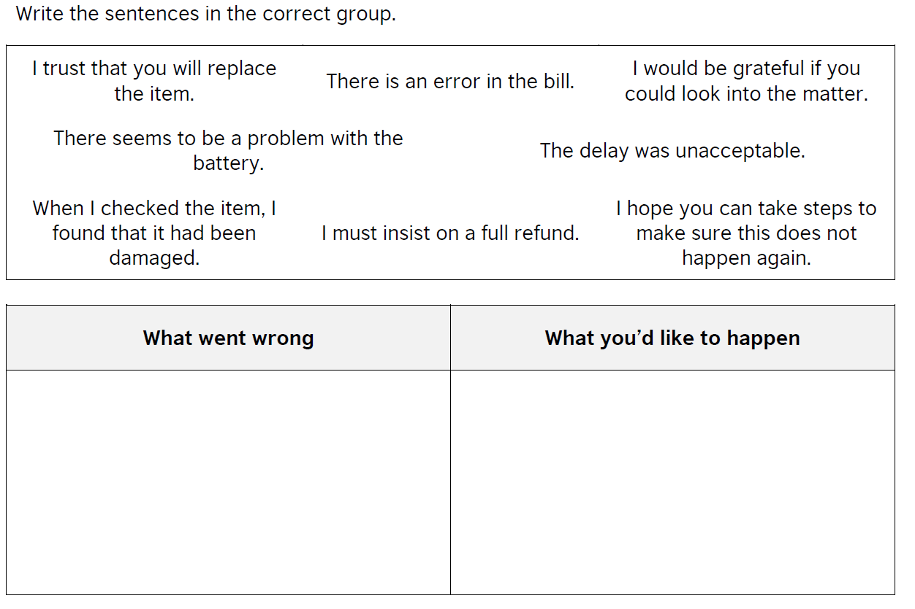
Task 3
Rewrite these sentences using the correct verb
checked say realized make corrected served

- The pharmacist………………. me within ten minutes.
- I…………………………… the pharmacist had given me the wrong medicine.
- The pharmacist should have …………………the prescription more carefully.
- The pharmacist ……………………………..the mistake.
- The pharmacist must not ………………. this mistake again.

